Question 1

Create a new user named ComputerScience and include the following tables.

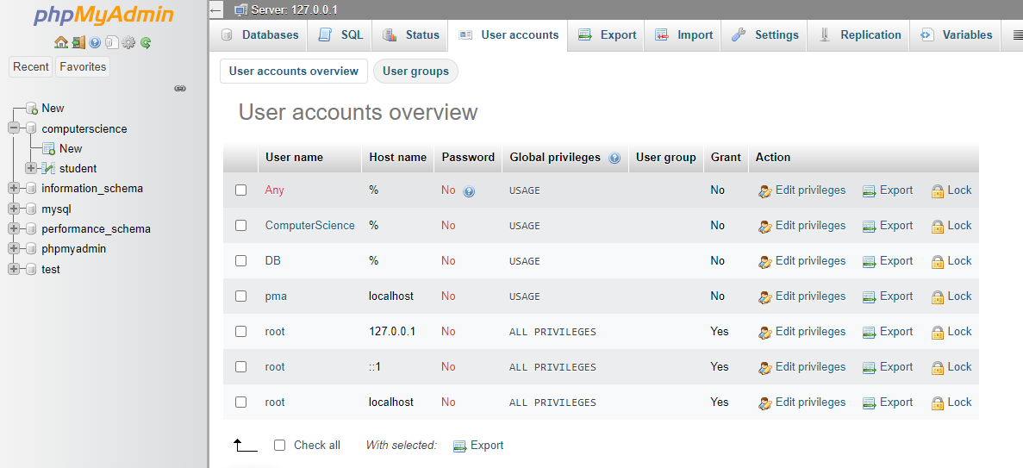

CREATE USER ComputerScience;

CREATE DATABASE ComputerScience;

**STUDENT**

|  |  |  |  |
| --- | --- | --- | --- |
| Name | Student_number | Class | Specialism |
| Smith | 10 | A | ComputerScience |
| Allan | 57 | B | ComputerScience |

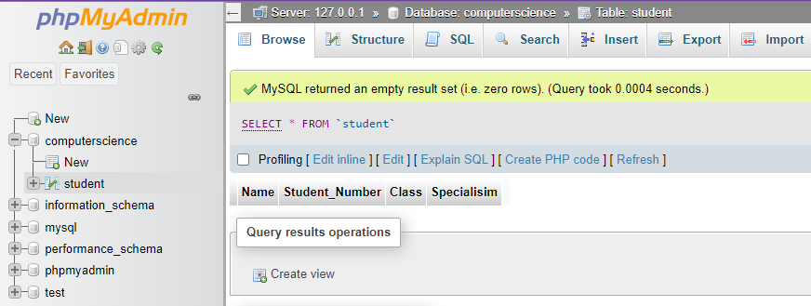

CREATE TABLE Student (Name varchar (100), Student_Number integer (2), Class varchar (1), Specialisim varchar (100));

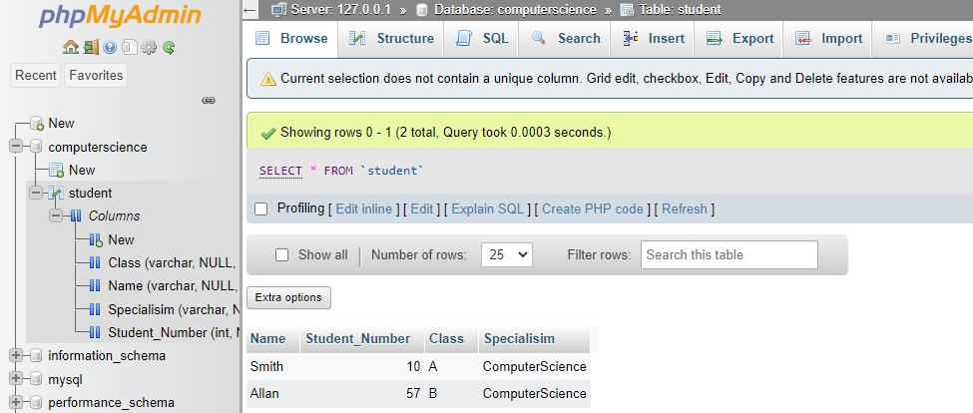

INSERT INTO Student (Class, Name, Specialisim, Student_Number ) VALUES ('A', 'Smith', 'ComputerScience', 10);

INSERT INTO Student (Class, Name, Specialisim, Student_Number ) VALUES ('B', 'Allan', 'ComputerScience', 57);

**COURSE**

|  |  |  |  |
| --- | --- | --- | --- |
| **Course_number** | **Course_name** | **Credit_points** | **Department** |
| DBA1202 | Collaborative Development | 10 | ComputerScience |
| CS5000 | Concepts of AI | 10 | ComputerScience |
| DA20221 | Programming | 8 | Maths |
| MC4100 | Advanced Databases | 10 | ComputerScience |

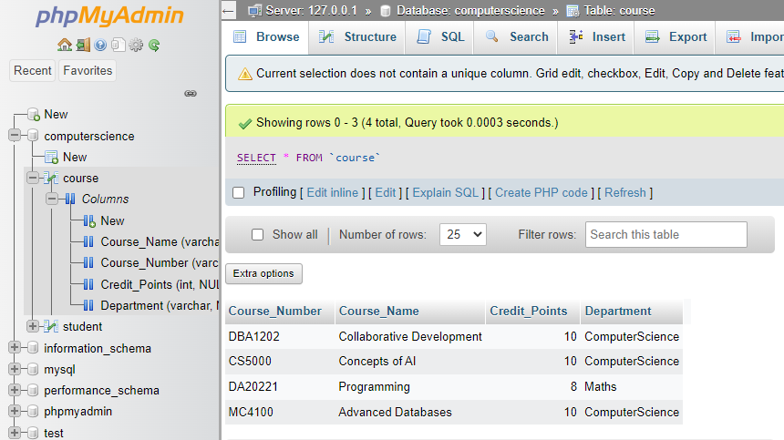

CREATE TABLE Course (Course_Number varchar(7), Course_Name varchar(100), Credit_Points integer(2), Department varchar(25));

INSERT INTO course (Course_Name, Course_Number, Credit_Points, Department) VALUES ('Collaborative Development', 'DBA1202', 10, 'ComputerScience'), ('Concepts of AI', 'CS5000', 10, 'ComputerScience'), ('Programming', 'DA20221', 8, 'Maths'), ('Advanced Databases', 'MC4100', 10, 'ComputerScience');

**STUDENT_GRADE**

|  |  |  |
| --- | --- | --- |
| Student-number | Course_number | Grade |
| 10 | DBA1202 | D |
| 10 | CS5000 | A |
| 10 | MC4100 | B |
| 57 | DBA1202 | C |
| 57 | MC4100 | F |
| 10 | DA20221 | E |

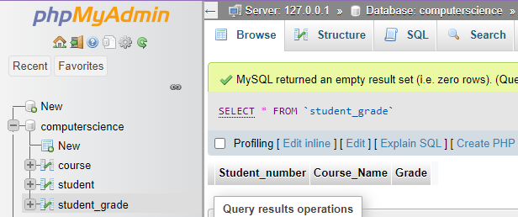

CREATE TABLE student_grade (Student_number int(2), Course_Name varchar(100), Grade char(1));

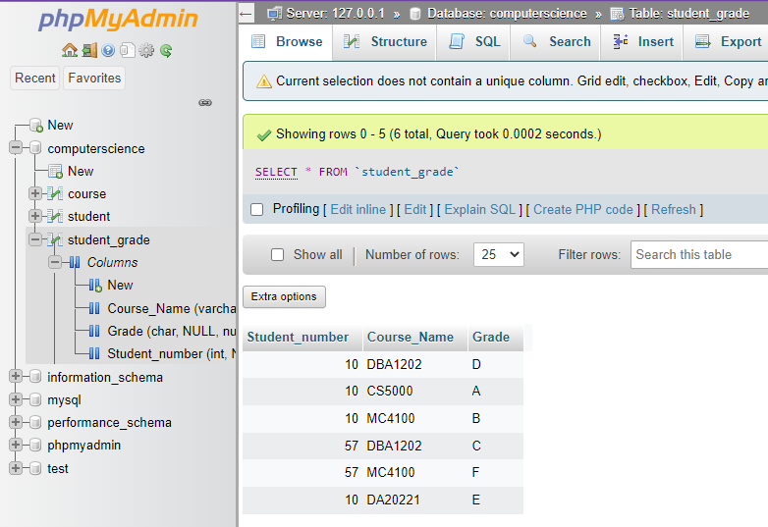

INSERT INTO student_grade(Student_number, Course_Name, Grade) VALUES (10, 'DBA1202', 'D'), (10, 'CS5000', 'A'), (10, 'MC4100', 'B'), (57, 'DBA1202', 'C'), (57, 'MC4100', 'F'), (10, 'DA20221', 'E');

**Question 2:** Define the following terms and explain with an example

* **Application:**

Application is a computer program that carries out specific task that is not related to the operation of the system. E.g.: VLC media player, Google Chrome etc.

* **Data vs Information:**

|  |  |
| --- | --- |
| **Data** | **Information** |
| * Raw facts and figures * Unprocessed Information * Data doesn’t depend on information | * Collection of data that gives us something meaningful * Processed Data * Information depends on data. |
|  |  |

* **Database:**

Database is a systematic collection of information stored together electronically with less to none data redundancy for easy access and use.

* **DBMS:**

DBMS or Database Management System is a system that is used to create, update and manage in a systematic way. It acts as an interface for us to interact with the database.

**Question 3:** Explain the Database Design process and importance of the Database Management system.

* Database Design Process:
* **Requirement’s analysis:** Research about the requirement of the database, assess the informational needs of the project so that the design can be made to meet those needs.
* **Logical Design:** Create a conceptual model an ER diagram that shows tables, rows, columns, primary keys etc. Then normalize the ER diagram. The normalization process will resolve any problems with database design.
* **Physical Design:** This step’s main function is to maximize the efficiency of database. It means finding a way to speed up the performance of database i.e., it’s read and write functionality
* **Implementation:** During this phase the tables, rows, columns etc. implemented in the ER diagram are written down as SQL queries and these statements are executed to create a database.
* **Monitoring, modification and maintenance**: Monitoring that the database does not have any unauthorized access. Making necessary modifications such as adding rows, columns etc. according to the needs of the project as time passes on. Finally ensuring the periodic backup of database falls under maintenance.
* **Database Management System importance:**
* Reduce data redundancy
* Sharing of data
* Data integrity
* Data Security
* Privacy
* Backup and Restore
* Data Consistency

**Question 4:** What is the role of a database administrator? Explain in detail.

A database administrator is an information technician who is responsible for managing or performing all tasks related to the database's successful operation. A database administrator ensures that a company's database and related applications are up to date and working properly.

Key roles include:

* Install and manage database servers' performance
* Create procedures for improving database security
* Establish and uphold database standards
* Control who has access to the database
* Increase the efficiency of database, fine tune it
* Database applications must be installed, upgraded, and managed
* Diagnose and resolve database problems

**Question 5:** Write the SQL syntax of **create, update, delete and insert** along with the example.

**SQL syntaxes:**

* **Create:**

CREATE table HCK (ID int, Name varchar (25), Marks int);

* **Update:**

UPDATE HCK SET Name = 'Nayan Raj Khanal', Marks= 70 WHERE ID = 1;

* **Delete:**

DELETE FROM HCK WHERE Name='Nayan Raj Khanal';

* **Insert:**

INSERT INTO HCK (LNAME, CITY) VALUES ('KHANAL', 'DHARAN');